* **What is Office 365?**

When I first heard this name “Office 356” I thought it is new version of Microsoft World office and new office capability. So I thought to dig into it, but this came up as surprise package for me. This is just awesome online services which boost up the Microsoft office’s capabilities to major extent. **Office 365 providers access virtually anywhere access to office tools, plus enterprise-grade email , conferencing and more it service.**

In other world (Glossary of Terms), Office 365 is a product and services bundle from Microsoft that includes Microsoft Online Services as well as domain administration tools, additional account storage space and increased vendor support.

Next question come up in mind “How does it work”? So let’s start with office 365 and then other tools or capabilities.

* **In this document, we will run through following things**
* Creating free office 365 account
* activate “Napa” web based tool which is great way to get started build apps for office or SharePoint directly out of a browser windows
* Then Publish and Add App in our test SharePoint server.
* **To play with office 365 features,**
* First we need to create an account in office 365,
  + get your developer site
    - Install Napa tools
      * Create your first App.
* **To Get Account in Office 365(free 30 days trail)**

<https://portal.microsoftonline.com/Signup/MainSignUp.aspx?OfferId=6881A1CB-F4EB-4db3-9F18-388898DAF510&DL=DEVELOPERPACK>

Follow the instructions and create a trail account (you can buy as well) which will give you developer site. During signup, you’re asked to supply a subdomain of .onmicrosoft.com, and you will have to used resulted user id (format is [userid@yourdomain.onmicrosoft.com](mailto:userid@yourdomain.onmicrosoft.com))

When you subscribed the office 365 you will get the following features

* SharePoint Online developer site
* Provider customized view for creating and testing apps
* Allow you can install "Napa" Office 365 Development Tools.
* Office Plus /Exchange Online

<http://msdn.microsoft.com/en-us/library/jj220038.aspx>

Once you done with Account creation, you will lend into office 365 admin centers, as you can see it does have lots of features/capabilities.

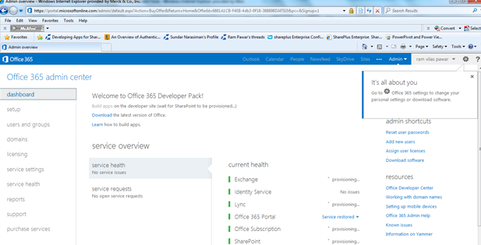

* **Start with Developer Site**

Here is you default developer site home page, you can see my developer site url ,

[https://rvpmca.sharepoint.com/(<mydomain>.sharepoint.com)](https://rvpmca.sharepoint.com/(%3cmydomain%3e.sharepoint.com)).

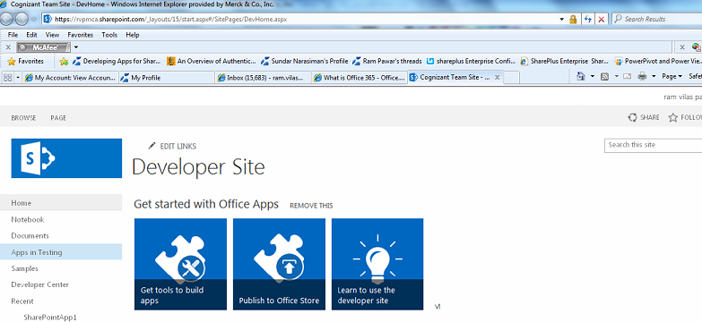

So one you finish provisioning then you can start developing the apps.

To do you have two options

* Use Visual studio 2012
* OR “NAPA office 365 development tools”
* **NAPA office 365 development tools**

Here we will be discussing the NAPA office 365 development tools. To get the NAVA Development tools, you need to open developer Site hope page.

* Click the Get Tools to Build Apps
  + Then click on ADD IT to install the "Napa” app Office 365 Development Tools
  + Choose the Trust It button in the next window.
  + You’ll be granted a license for the app. Leave the installation check box selected, and then click the Return to site link.

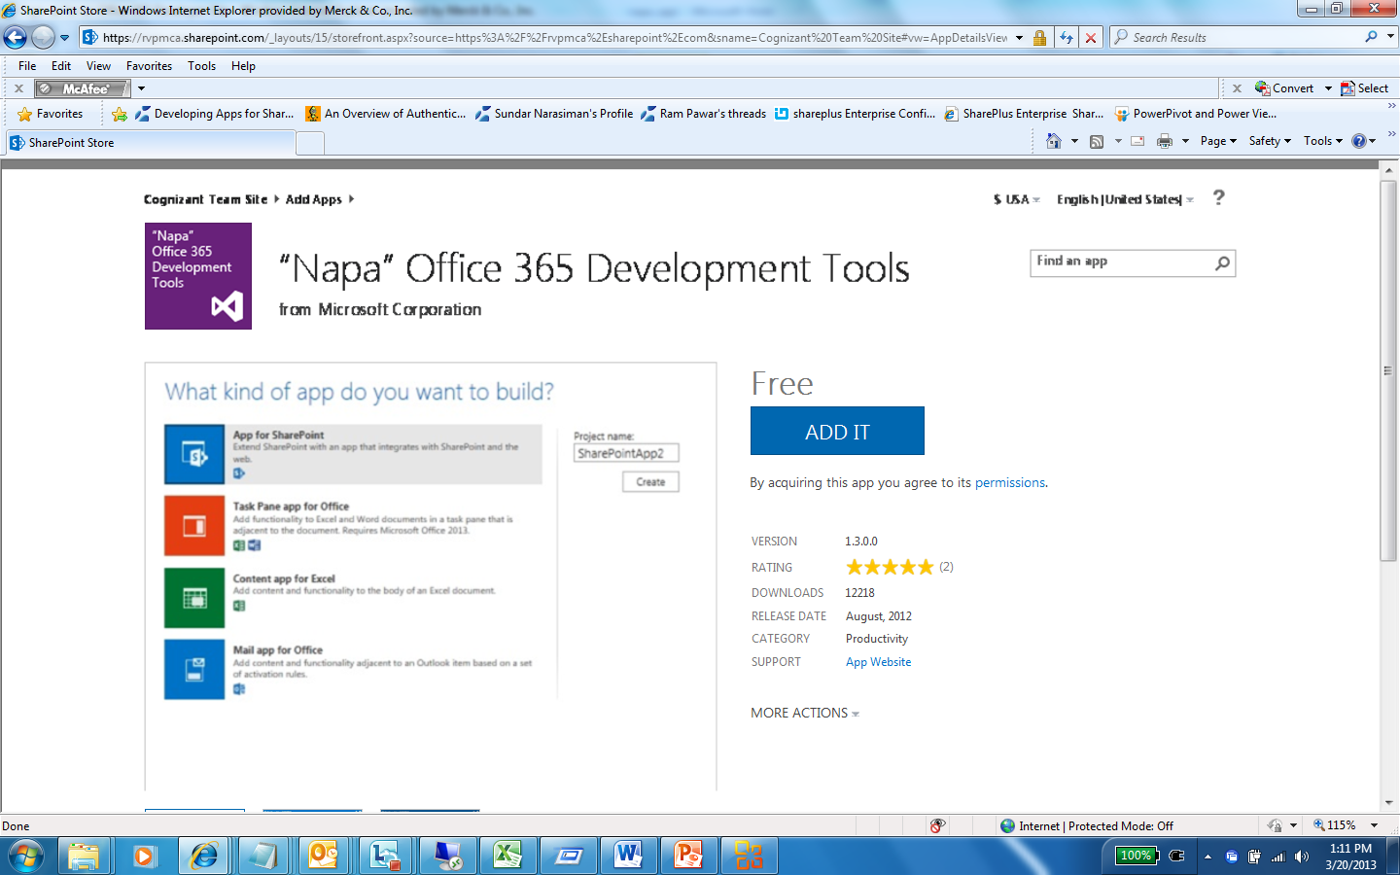

Once you finish your installation, you can see Napa office 365 developer tools under “Site Contents”,

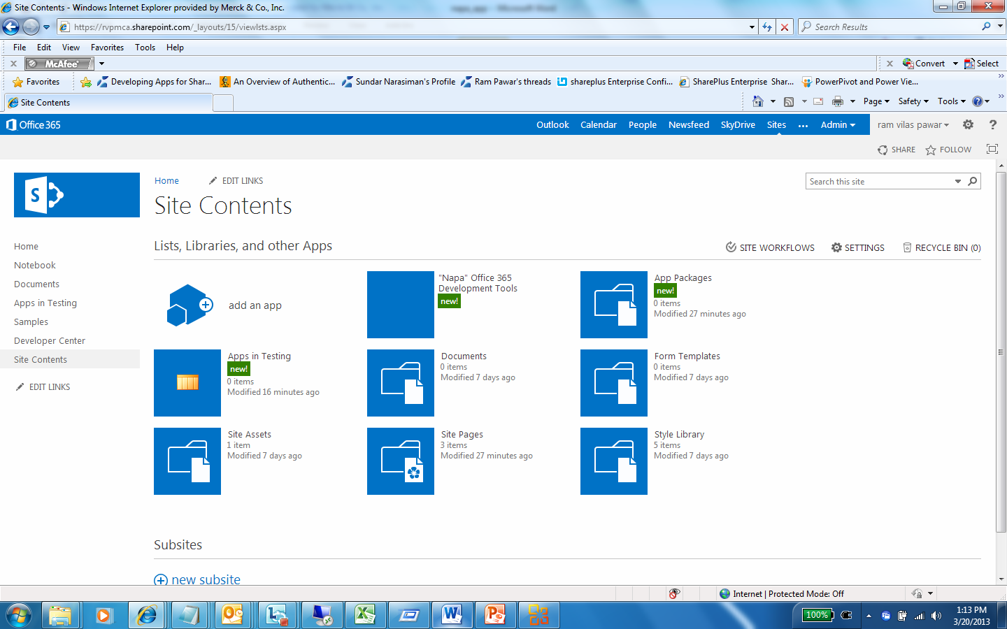

Click on app, It will open Napa editor tools and you can see it offers you many inbuilt apps to create but here we will talk about “Creating basic app for SharePoint” .

* Please enter SharePoint app name then click on Create.

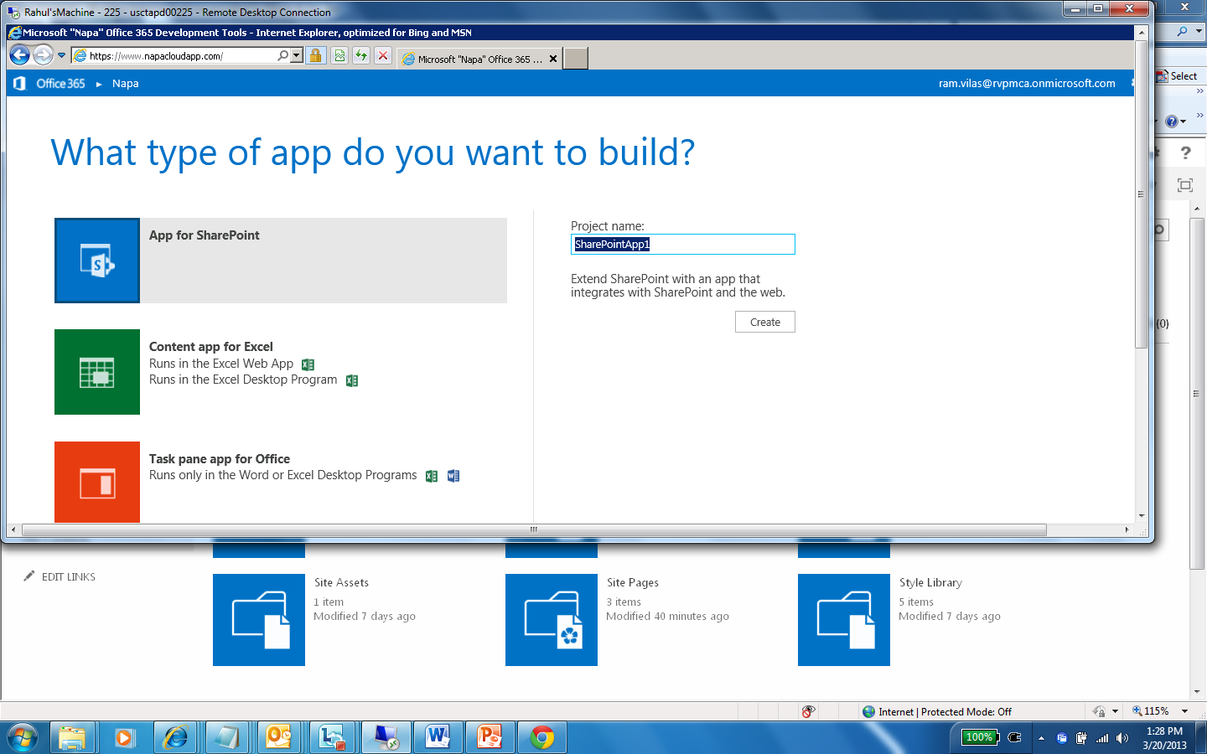

Then it will open Naga editor. By defaults it will create one basic schema of apps

1. Content
2. Images
3. Pages
4. Scripts

You can update it as per you requirement, but here I will just updated the test as I just want to understand whole process first then we will go in deep development ☺

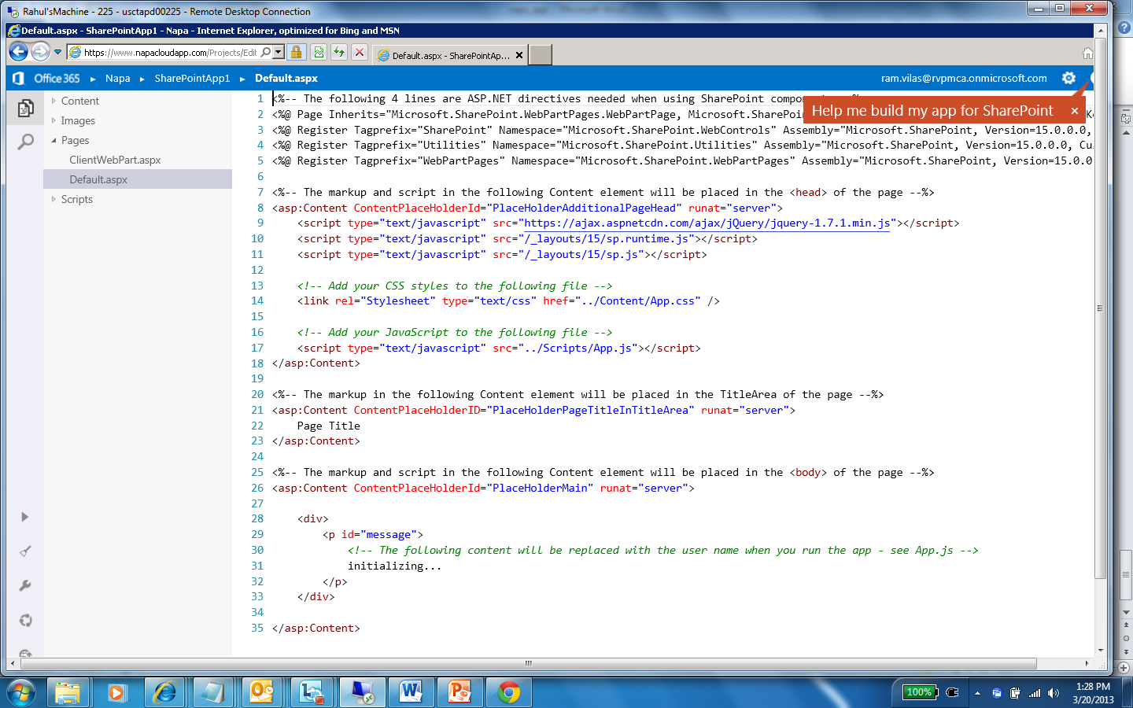

Once you done, click on arrow “Run Project” , it will install Apps on your Developer Site

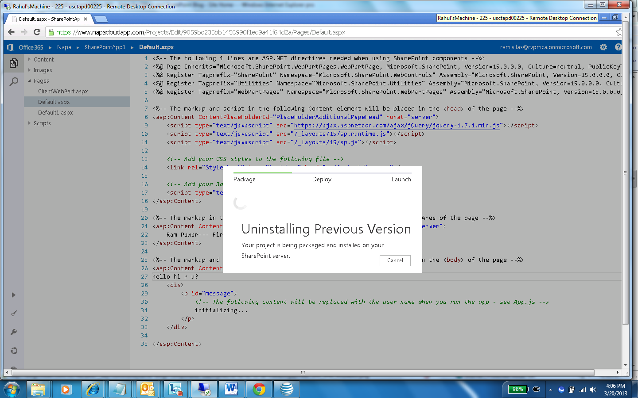

Now you done, go back to you developer site and edit home page and go to “Insert” and Apps then select your app and Save it. And here you have create first Sharepoint app ☺

